



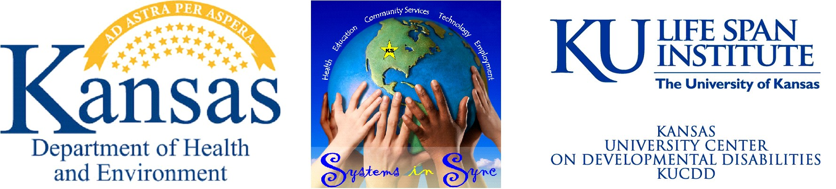
Transitioning Youth with Special Health Care Needs and
Disabilities to Adult Life Webinar Series

Join us to learn about a cool new online tool you can use to help prepare you for adulthood!

The online program will help you learn about:

∗ YOU—Discovering your abilities & where you can become more independent.

∗ MAKING CHOICES—Making good decisions about your needs & setting goals.

∗ LOOK GOOD AND FEEL GOOD—Eating healthy, exercise tips that work for you, staying healthy mentally & avoiding peer pressure.

∗ BEING PREPARED—Preparing for doctor’s visits, understanding your medical & disability needs, and clearly sharing about your needs to medical professionals and parents

∗ INDEPDENDENCE—Setting goals to be a healthier & more independent you!

∗ YOUR FUTURE—Finding a job, preparing for amazing interviews, & picking a college.

It is YOUR Life, so Plan It, Live It!

Tuesday, December 11, 2012
4:00 to 4:45 pm

https://www1.gotomeeting.com/register/876047601

Questions? Contact Heather at 785-296-4747
or hsmith@kdheks.gov.

This project was funded by the U.S. Department of Health & Human Services, Health Resources and Services Administration, Maternal and Child Health Bureau (award #D70MC12837) awarded to the Kansas Department of Health Environment.

